

**Virtual Volunteer Centre**  
Tool Kit

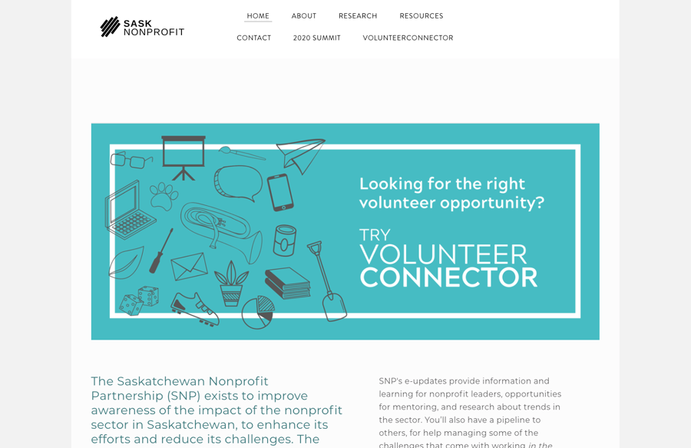

**Create a profile**  
With support from VolunteerConnector, sign-in   
as an organization, add a logo and fill out the profile section. Once completed contact VolunteerConnector, who will tag your account as a Regional Partner.   
  
While logged in to the site you may add people within the organization who may want to access the VolunteerConnector. This can be done with just their email address, first and last name. When people leave the organization, they will need to be deactivated.

**Define the community you will help**  
Determine the geographical reach you want to have and communicate this to VolunteerConnector.

**Promote the tool**

a) Communicate the transition to VolunteerConnector to community organizations and volunteers. Refer to the VolunteerConnector email templates below that are available to be customized with local branding.

b) Establish a link to the Connector from the Regional Host Organization’s website:

* People who are looking to volunteer in the region.   
  [www.volunteerconnector.org/](https://www.volunteerconnector.org/)
* Organizations who want to advertise for volunteers on the VolunteerConnector.   
  [www.volunteerconnector.org/organizations/login](https://www.volunteerconnector.org/organizations/login)

**3**

**2**

**1**

**EXAMPLE ONE VISIT:**

[www.sasknonprofit.ca/](http://www.sasknonprofit.ca/)

Once this simple and easy toolkit is completed, you will be the virtual hub for volunteers and organizations in your community, and you will be able to keep a pulse on what volunteerism looks like through live data.

Become a Virtual Volunteer Centre Through **Volunteer**Connector

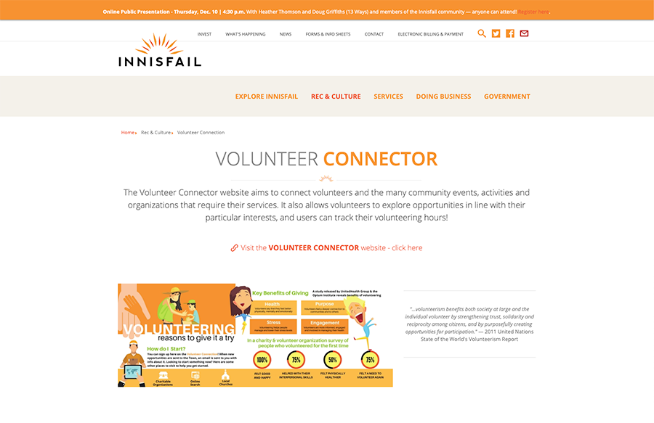

**4**

**3**

**2**

**1**

**4**

We are real humans that can help you. Day or night we are here to offer support and answer any questions you may have. Contact us any time at: info@volunteerconnector.org

**Monitoring**  
Sit back and watch – by monitoring the virtual volunteer centre dashboard, you will see how well promotions are working. Once there is an adequate number of views on the site and postings, promotion may be adjusted and reduced.

**Support organizations and volunteers**  
Should they need help logging in to the site. This is typically not a significant task, and if onerous, VolunteerConnector staff are willing to assist. Issues may be forwarded for resolution.

**Reporting**  
Pull reports to share with local stakeholders.

**Regional Feedback to VolunteerConnector**  
This is optional and variable as Virtual Volunteer Centre’s will be invited to test new features as they are developed, to provide feedback. This will help ensure that every community’s needs are being met.

Maintaining the site in the following ways will ensure your community’s needs around volunteerism are being met

**4**

**Support Organizations & Volunteers**

Support organizations and volunteers, should they need help logging in to the site. This is typically not a significant task, and if onerous, the staff at VolunteerConnector are on stand-by willing to assist, and issues may be forwarded for resolution.

**EXAMPLE TWO VISIT:**

[**innisfail.ca/parks-recreation/volunteer-opportunities**](https://innisfail.ca/parks-recreation/volunteer-opportunities)



**The platform that allows us to do this is called the VolunteerConnector and was created with three things in mind:**

1. Help communities provide more volunteer engagement and recruitment support   
   to organizations, as well as connect more community members to   
   causes they care about.
2. Make volunteer engagement easier. This platform has all the volunteer management tools built into it – recruitment, retention and screening, freeing   
   up time for the volunteer manager to focus on other work.
3. Provide us with insight into what volunteer engagement looks like in our community through live data.

NEW VIRTUAL VOLUNTEER CENTRE’S NAME is excited to tell you that we are officially a Virtual Volunteer Centre for our community! Our platform will help you connect with more engaged volunteers and streamline the whole volunteer engagement process.

Template 1 (delete this text before sending)

**Volunteer**Connector for Organizations

* Recruit volunteers quickly and easily with no limit on volunteer postings
* Volunteers can apply to posting seamlessly, and volunteers can track their hours!
* A dashboard to see your team at a glance, and there is no limit on the number of users per profile
* The ability to communicate directly with your volunteers
* Assign your volunteers roles within their organization
* Export your volunteer list for offline use at any time
* Get moving quickly by uploading your current volunteer list

The VolunteerConnector, has many exciting **features** that will make volunteer recruitment easier for you.



Organizations will also have the option to **upgrade** your membership anytime to a monthly subscription to get these benefits:

*If you have any questions, please reach out to* NEW VIRTUAL VOLUNTEER CENTRE *at* YOUR EMAIL ADDRESS, *we will be more than happy to support you in getting started!*

**Create a Profile for your Organization**

1. Go to [www.volunteerconnector.org/organizations/login](https://www.volunteerconnector.org/volunteer/apply)
2. Enter your email, and organizations name
3. Check your email to confirm registration
4. Create your password and log onto your   
   Organization Dashboard
5. Fill in the Organization Profile

**Create a Volunteer Posting**

1. Go to your Organization Dashboard
2. Click on ‘Create New Posting’
3. Fill in the volunteer posting template – make sure to check out the tips on the side of the template to create the most attractive posting.
4. Activate Posting or Click on Publish Later
5. Wait to hear from interested community members

Template 1 (delete this text before sending)

* Simple scheduling tools so you can ditch the spreadsheets
* Expanded dashboard to track the number of views your postings are receiving, the number of volunteers engaged and total number of volunteer hours
* Access to all new features as soon as they are ready
* Pause your upgraded membership anytime and   
  only pay for it when you are using it
* These features usually are $10 a month but   
  can be accessed for free for three months by requesting a code

You can start using the VolunteerConnector and begin recruiting volunteers right away by following the steps:

Once you have created on Organizational Profile, you can begin recruiting Volunteers.



1. Go to: [www.volunteerconnector.org/organizations/login](https://www.volunteerconnector.org/volunteer/apply)
2. Enter your email
3. Check your email to confirm registration
4. Create your password and log onto to the VolunteerConnector
5. Create a profile
6. Play around by browsing all the organizations and follow those of interest to stay up to date on the positions they are advertising for
7. Search Browse Opportunities to see all the volunteer positions in your community
8. Apply to the position you are most interested in to start volunteering!

*If you have any questions about this new website, please reach out to* YOUR LOCAL CONTACT’S NAME *with the* NEW VIRTUAL VOLUNTEER CENTRE’S NAME *at* YOUR EMAIL ADDRESS, *we will be more than happy to support you in getting started!*



NEW VIRTUAL VOLUNTEER CENTRE’S NAME is excited to tell you that we are officially a Virtual Volunteer Centre for our Community! We will help you find more volunteer opportunities in our community, and get you out in the community helping, faster!

The new platform that is making this possible is called the VolunteerConnector and was created to improve volunteers overall experience, by connecting you to opportunities that are meaningful and match your skills and interest.

Template 2 (delete this text before sending)

**Volunteer**Connector for Volunteers

**Some of these features include:**

* The ability to follow organizations that you are most interested in and stay informed when the organization posts new positions.
* The ability to create and save a personal profile saving you from having to complete multiple application forms.
* The ability to select the volunteer shifts that work best for you and keep a schedule of all your volunteer commitments.
* The ability to track all your volunteer hours.
* A one stop-shop for all the volunteer positions in our community and the surrounding area.
* Ability to tailor your search results based on your personal skills and interests.

*You can start using the VolunteerConnector and   
begin searching by going to* [www.volunteerconnector.org](http://www.volunteerconnector.org)

The **VolunteerConnector**, has many exciting features that will make it easier for you to find out what is happening in the voluntary sector in **Your Communities Name**



**Create a Volunteer Profile**